1. Odd String Difference

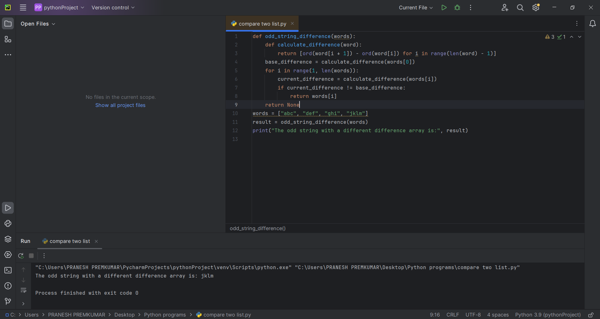

2. Words Within Two Edits of Dictionary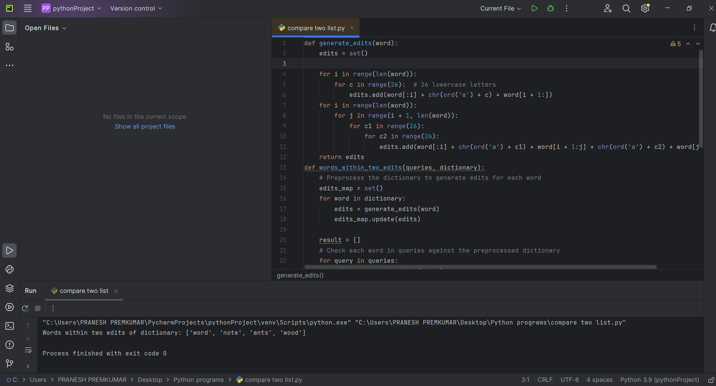

3. Next Greater Element IV

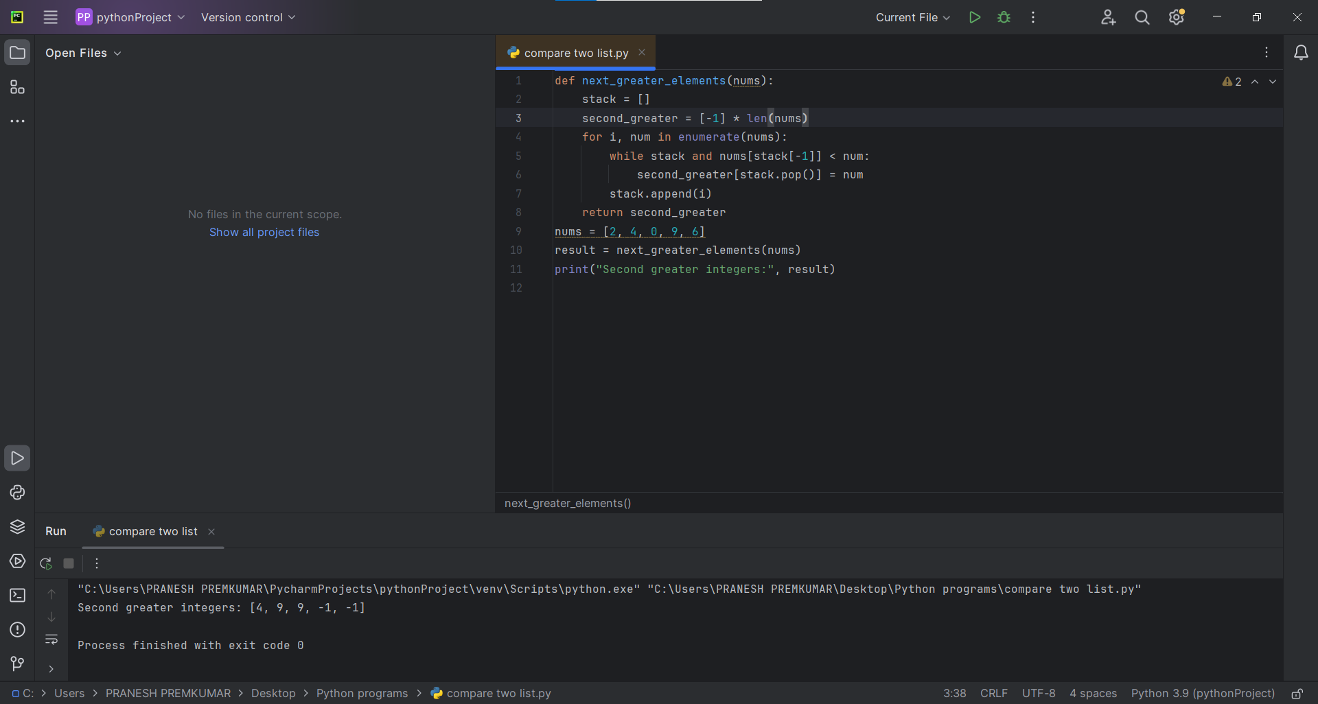

4. Minimum Addition to Make Integer Beautiful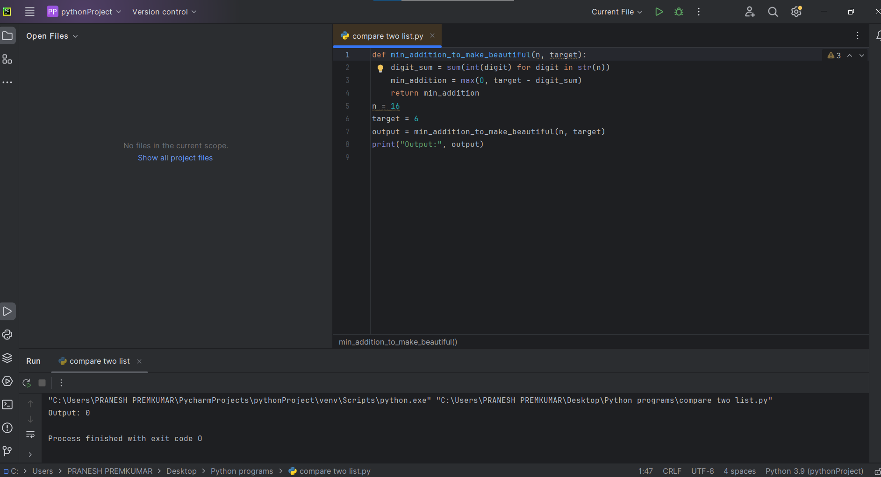

5. Sort Array by Moving Items to Empty Space

